Scratch Challenges

Challenge #1:

1 – Create a countdown

Add program start

Set a variable (storage location) called count to 1000

Add a repeat loop that repeats until count = 0

Set the variable count = count -1

Say count

End program

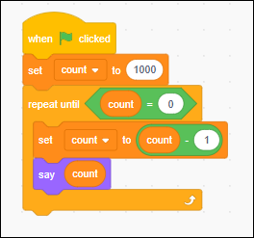

2 - Ask for 2 numbers and add together

Add program start

Ask for first number and store in variable

Ask for second number and store in variable

Wait until spacebar is pressed

Print the sum of the 2 numbers

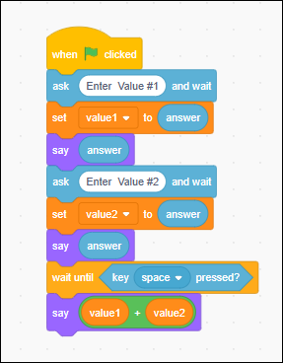

3 - Use the left and right arrow keys to increase a variable called count

Or decrease count

Say increase or decrease based on which key

If the left arrow is pressed then add 1 from count and say increase

If the right arrow is pressed then subtract 1 from count and say decrease

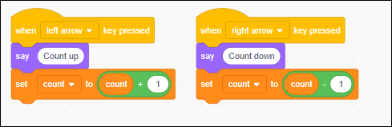

4 - Simulate autonomous flight plan (Stages)

When the space key is pressed

Create a flight plan list called stages

Add Takeoff to the list

Add Move to the list

Add Land to the list

Create and set a variable called stg to 1

Repeat

say the stage of flight plan using the list you created

Wait 5 seconds

Add 1 to the stg variable

